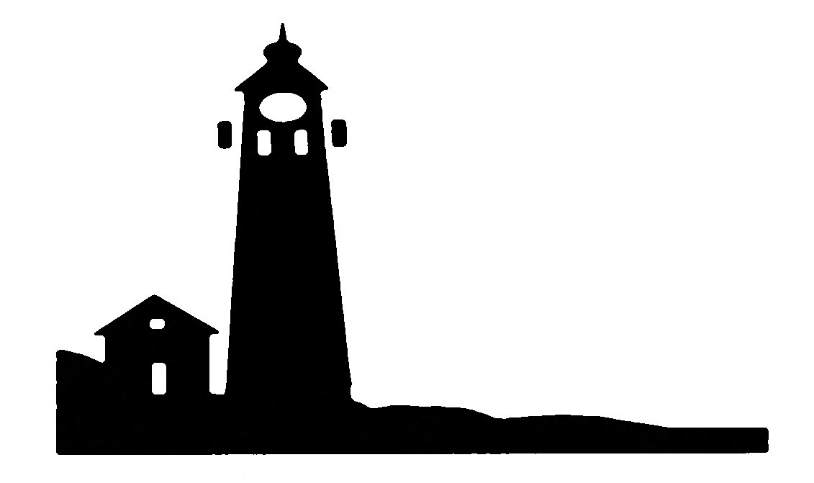
IOSCO REGIONAL EDUCATIONAL SERVICE AGENCY
27 N. Rempert Rd.
Tawas City, MI 48763
Phone 989.362.3006 / Fax 989.362.9076
www.ioscoresa.net

VACANCY NOTICE

POSITION TITLE: Special Education Teacher
Alternative Educational Academy of Ogemaw County, West Branch, MI

The Alternative Educational Academy of Ogemaw County is seeking a full-time Special Education teacher for our West Branch Campus. Our Charter School serves at-risk students in grades 6-12 using an online curriculum and provides teacher assistance at our learning lab located in the Michigan Works! Service Center

DATE POSTED: November 7, 2019

QUALIFICATIONS:
Education: Valid Michigan Special Education Teacher Certification

Experience: Prefer three (3) years’ experience, working with Alternative High School Students helpful

Role: Developing and implementing individualized programs of instruction to meet the needs of students in grades 6-12;
Scheduling, planning and conducting individual education plan meetings;
Guiding students in determining their post-secondary goals and implementing appropriate strategies and activities to ensure students are able to reach their post-secondary transition goals;
Collaborating with school stakeholders and community agencies providing supportive services for Special Education students;
Participating as an educational team member for the success of all students;
Maintaining and documenting weekly two-way communication with an assigned student caseload;
Other duties as assigned.

REPORTS TO: Director of the Alternative Educational Academy of Iosco County

APPLICATION DEADLINE: November 21, 2019 or until filled

APPLICATION PROCESS: Send letter of application, resume, references, and transcripts to:
Iosco Regional Educational Service Agency
Attn: R. Foster
27 N Rempert Rd
Tawas City, MI

989.362.9076 fax

Email: rfoster@ioscoresa.net

The Iosco Regional Educational Service Agency does not discriminate on the basis of race, color, national origin, sex (including sexual orientation and transgender identity), disability, age, religion, height, weight, marital or family status, military status, ancestry, genetic information or any other legally protected category, (collectively, "Protected Classes"), in its programs and activities, including employment opportunities.

